AI-POWERED MEDICAL LAB REPORT ANALYSIS AND HEALTH INSIGHTS PLATFORM
Scope and Limitations
Department of Computer Science and Engineering, TKR College of Engineering and Technology (Autonomous)
Batch A8 (CSE-A) · Academic year 2026-2027
Table 1: Project team
S.No. | Student name | Roll number
1 | BANOTH SWAPNA | 23K91A0528
2 | BEKKAM VARSHITHA | 23K91A0535
3 | A NAVADEEP REDDY | 23K91A0502
4 | BUDIGAM MANOJ | 23K91A0546

Project guide: L.G REDDY
Chapter and section numbers quoted in the text (for example Section 6.6 or Chapter 8) refer to the full project report, 17.Final Document. Figures and tables in this document are numbered from 1.

1. SCOPE
LabLens is an educational tool that helps a reader understand the structure of a laboratory report. The boundaries of what it does and does not do are listed explicitly, because the product handles health information and users must not over-trust it.

1.1 In scope
• Upload of PDF, JPG, JPEG and PNG reports up to 15 MB. Digital PDFs are read from their text layer; scanned pages and photographs go through OpenCV clean-up and Tesseract OCR.
• Line-oriented extraction of test name, numeric result, unit, reference range (two-sided such as 12 - 16, one-sided such as <100 or >40) and report date.
• Snapping of noisy test names to a dictionary of 55 common tests with a TF-IDF character n-gram matcher (cosine threshold 0.55).
• Classification of every result as LOW, NORMAL, HIGH or UNKNOWN against the reference range printed on the same report (limits inclusive).
• Plain-language insight cards for every LOW or HIGH result: what the test measures, general possible causes and a suggestion to consult a doctor. An optional LLM rewrite is available when an API key is configured.
• A SQLite library of reports, results and insights, with a dashboard, report list, report analysis, health trends, report comparison and insights pages.
• A FastAPI service and a React interface with a demo login, plus the original Streamlit application; five synthetic sample reports for first use; an automated test suite.

1.2 Out of scope
• Diagnosis or treatment advice. The system is an educational aid, not a medical device, and every screen carries a disclaimer.
• The abstract's PP-OCR engine, CRF-based NER model, retrieval-augmented generation over a medical knowledge base, Supabase with row-level security, Tailwind CSS and Google Cloud Functions. None of these was built (Section 3.1 explains why).
• Age- or sex-specific reference ranges. The range printed on the report is used as given.
• Handwritten reports, non-Latin scripts, and layouts in which every table cell is a separate line of text (measured recall 0 on such reports).
• Per-user data separation, registration, HTTPS, encryption at rest and audit logging; only one shared demo account exists.
• Validation on real patient reports or against manually labelled reports. No such data was available to the project.
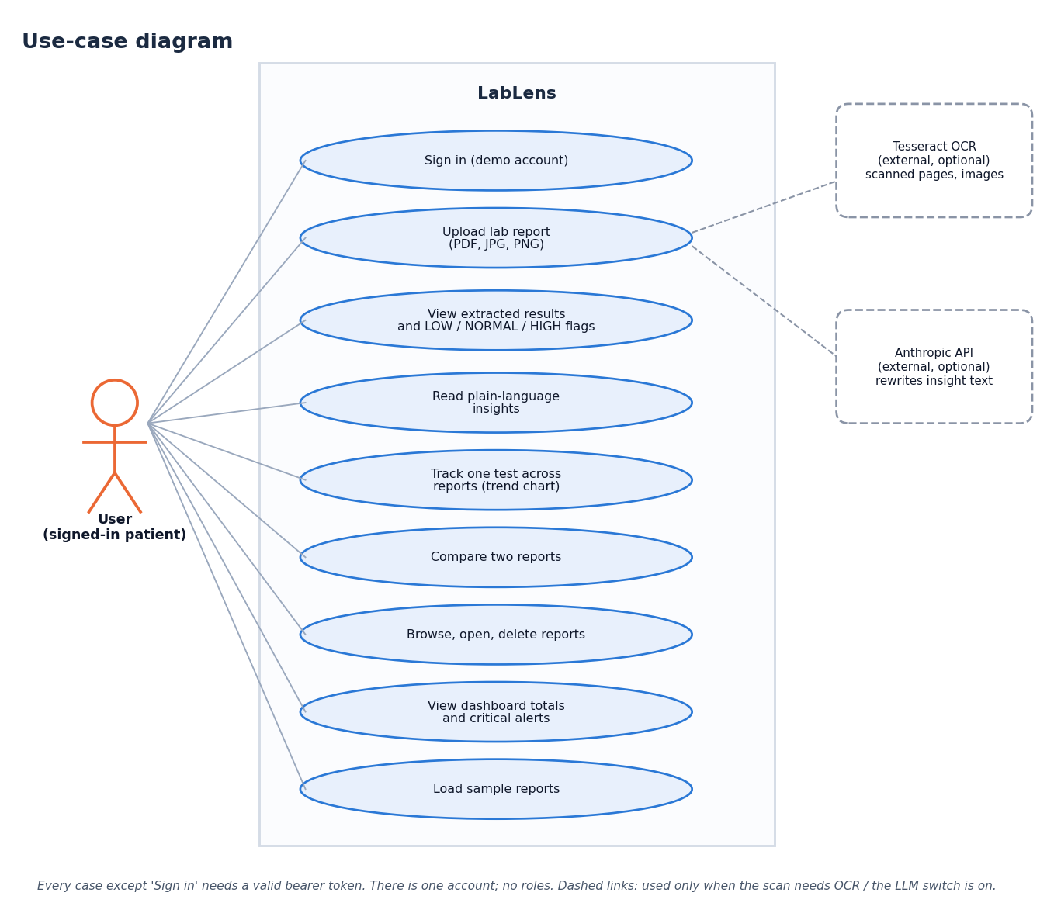
Figure 1: What the user can do within the scope of the system (use-case diagram)

2. ASSUMPTIONS
The design and every measurement in this report rest on the following assumptions. If one fails, results degrade as described under the limitations.
• A report lists one test per line in the order name, result, unit, reference range (or a close variant) and prints a reference range for each test.
• The input is a PDF with a text layer, or a legible scan or photograph in English and Latin script, no larger than 15 MB.
• The reference range printed on the report is the correct range for the patient; the application does not adjust it.
• One trusted user group on one machine. The demo account is a convenience, not an identity system.
• The host has Python 3.11 or newer and Node.js 20 or newer; Tesseract OCR is installed only if images or scans are to be read.
Constraints of the build itself: the work was done by a four-member team on one desktop computer without a GPU, with no access to real patient reports, no Tesseract installation on the measurement machine and no LLM API key. Each constraint shaped what could be measured.

3. LIMITATIONS
The limitations below come from measurement, not from speculation. Each is traced to a table or a failure case in Chapter 8.
• Layout dependence. On reports where each table cell is a separate text line, the parser extracted no rows at all (recall 0.000 on 210 rows); a date line such as 12-04-2026 was read as a test named "Sample Collected" in every one of the 56 corpus reports that print the date with hyphens.
• Unit gaps. Unit accuracy is 87.1% overall and 57.6% when a flag letter sits between the value and the unit; units such as mg/L, umol/L, ng/dL and uIU/mL are not in the parser's unit list.
• Name matching. The TF-IDF matcher loses accuracy under character noise (89.0% at 10% noise against 98.1% for a plain difflib baseline) and renames some unseen tests, for example Sodium Bicarbonate to Sodium.
• Thin explanation coverage. Only 17 of the 55 dictionary tests (30.9%) have test-specific explanation text; the rest receive a generic paragraph. The explanations are rule-based, with no retrieval and no citations.
• Evaluation data. All accuracy figures come from 120 generated reports (1,680 rows) with generated ground truth, not from real, manually labelled reports. Scanned-image OCR accuracy and latency were not measured because Tesseract was not installed on the test machine, and the optional LLM rewrite was not exercised.
• Trends. Trend direction compares only the first and last values, and the time axis is the upload date, not the date the sample was taken.
• Demonstration-grade security and not a medical device: outputs must not be used as the sole basis for any health decision.
Table 2: Effect of the main limitations on a user
Limitation | What the user sees | Remedy (see future scope)
Cell-per-line tables unsupported | report marked Failed, or a single bogus row if the date uses hyphens | table-aware parser using word positions
Date line read as a test | an extra Sample Collected row; test count one too high | reject rows whose range contains a year or whose name is a header word
Unit list incomplete | unit shown as blank; value and flag still right | extend the unit expression; read units from the range side
Name snapping to a wrong test | a result plotted under the wrong test | word-boundary and length checks, synonym table, show a confidence badge
Thin explanation coverage | generic text for 64% of abnormal rows | extend the knowledge base; add cited retrieval

The extraction F1 of 0.916 should be read with the corpus caveat: it comes from generated reports and probably overstates performance on real ones.

4. WHAT WAS NOT MEASURED
Several things a reader might expect have no number in this report. They are listed here so that their absence is not mistaken for a result.
Table 3: Not measured
Item | Reason | Consequence
Accuracy and latency of scanned-image and photograph OCR | Tesseract is not installed on the measurement machine | the OpenCV + Tesseract path is untested; the abstract's low-quality-scan claim is unsupported
Comparison with PP-OCR | PP-OCR was not integrated | no evidence either way for the abstract's choice
Quality of the optional LLM rewrite | no ANTHROPIC_API_KEY was available | its wording, correctness and latency are unknown
Helpfulness and correctness of explanations | no clinician or model rating was done | coverage is counted, quality is not
Accuracy on real, manually labelled reports | no such reports were available | the corpus is generated; real-world accuracy is unknown
Many simultaneous users, large libraries | single-user tests only | scalability of SQLite and the in-process pipeline is unknown
Responsive and accessibility checks | scripts/ui_check.py was not re-run for this report | the screens were seen at 1440 x 900 only in these documents

